***Job Scheduling Algorithm with Cost Savings and Reasonable Turnaround Time***

Frederick Jack 45511020

# Introduction

In a distributed system, job allocation is very important for the efficient use of resources. Scheduling is a decision-making process that typically uses an optimizing algorithm for the dispatching of jobs. This project implements a client-side job scheduler working with a distributed systems server simulator. The client is connected through a socket, so it is language independent, but this implementation is written in Java. The goal at this stage of the project is to successfully schedule and complete all available jobs. the aim is to save on costs with a turnaround time that is comparable to a worst fit algorithm without failures.

The main goal of task two is the creation of an algorithm that successfully schedules all jobs. There needs to be efficient use of costs with an acceptable turnaround time.

# Problem Definition

When using a distributed system of servers, one of the main goals is efficient use of resources when scheduling jobs. This can be defined along many different parameters such as turnaround time, resource utilisation, and cost savings. With this project the main issue that will be addressed is whether there can be an improvement over four algorithms that are already defined: all jobs to the largest server (ATL), best fit (BF), first fit (FF), and worst fit (WF). It is already assumed that the reader will be familiar with the algorithms. The relevance of this problem is that there can be less power consumption, increased savings for the customer and a faster processing of “jobs”. The objective is to create a “significantly” different algorithm that is superior in performance in terms of cost savings and turnaround time.

# Algorithm Description

* Uses TERM command to stop idle servers and increase resource utilization.
* GETS Avail command is used to get servers that are currently not processing other jobs to speed up execution time.
* Two lists of servers are used: A dynamic one with currently available servers and a static list of servers that is created with each xml file that is used.
* Algorithm searches for a server within 7 cores of the cores required for the job. It also requires that the server has more memory and disk space available for processing the job, so the Client does not crash.
* If you increase the difference of number of cores required to higher than 7 then there is a lower turnaround time.
* If you decrease the difference of number of cores required to lower than 7 then the total cost is lowered.
* When there are no “available” servers the algorithm reverts to the static server list and selects a server with enough cores, memory, and disk to handle the job.
* When a server is selected from the static server list a randomised server is picked between 0 and the limit minus one to evenly distribute the jobs.

# Implementation

The client is implemented with Java version 8. The IDE used for the project was IntelliJ. The provided ds-server simulator is written with the C programming language. The Client and Server were tested using Ubuntu 20.04 with a VirtualBox virtual machine.

#### Client Class/Main

The Client class contains the main method for running the Client and contains all the methods for sending and receiving messages and the algorithm methods. It initiates the connection and contains the event loop method which was the process for scheduling jobs.

#### Server Class

The Server class contains the variables of what the GETS Avail command returns. This information is stored as an object in an array list, and it dynamically changes with each request of available servers. The array list is cleared after each job is scheduled.

#### XML Class

The XML class parses the ds-system.xml generated by the ds-sim Server. It stores the details of each server in an object array list.

#### StaticServerList Class

The StaticServerList class contains the variables of the static server list that is generated by the ds-system.xml file. The details of each static server are stored as an object in an array list.

# Evaluation

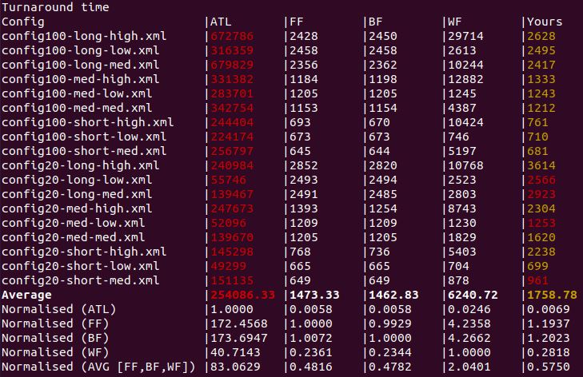

* When there was a high number of jobs the custom algorithm performed almost as well as BF and FF (figures vs figures) and was much better than ATL and WF in turnaround time (A vs B).
* The algorithm performed closest to FF in terms of turnaround time when there was a “high” number of jobs.

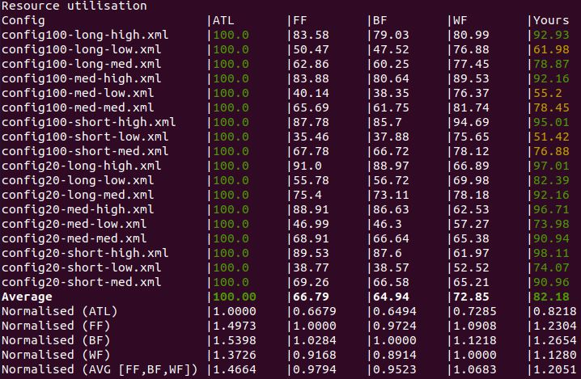

* In terms of resource utilisation the algorithm performed the worst when there were a “low” number jobs. In those cases, it performed worse than the WF algorithm. In most other cases it had the best resource utilisation of BF, FF and WF.

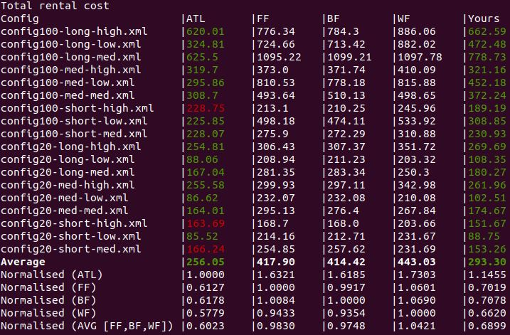

* *In terms of each configuration file ATL*

# Conclusion

The algorithm almost offers an average cost improvement over at ATL option which is the best performing in terms of cost. The combination of total rental cost and turnaround time makes it the most well-rounded option out of the other four algorithms. One of the limitations of the algorithm is that the TERM command makes an idle server inactive and there is an associated bootup time once it is needed again which increases the turnaround time slightly.

# References

GitHub repository: <https://github.com/fjack2114/COMP3100-Stage-2>